**WEEK 4 HANDSON**

**Hands on 2**

**Spring Core – Load SimpleDateFormat from Spring Configuration XML**   
  
SimpleDateFormat with the pattern ‘dd/MM/yyyy’ is created in multiple places of an application. To avoid creation of SimpleDateFormat in multiple places, define a bean in Spring XML Configuration file and retrieve the date.  
  
Follow steps below to implement:

* Create spring configuration file date-format.xml in src/main/resources folder of 'spring-learn' project
* Open https://docs.spring.io/spring-framework/docs/current/spring-framework-reference/core.html#beans-factory-metadata
* Copy the XML defined in the section of previous step URL and paste it into date-format.xml
* Define bean tag in the XML with for date format. Refer code below.

**CODES AND OUTPUTS** :

**SpringLearnApplication.java**

package com.cognizant.spring_learn;  
  
import java.text.ParseException;  
import java.text.SimpleDateFormat;  
import java.util.Date;  
  
import org.slf4j.Logger;  
import org.slf4j.LoggerFactory;  
import org.springframework.boot.SpringApplication;  
import org.springframework.boot.autoconfigure.SpringBootApplication;  
import org.springframework.context.ApplicationContext;  
import org.springframework.context.support.ClassPathXmlApplicationContext;  
  
@SpringBootApplication  
public class SpringLearnApplication {  
  
 private static final Logger *LOGGER* = LoggerFactory.*getLogger*(SpringLearnApplication.class);  
  
 public static void main(String[] args) {  
 *LOGGER*.info("START");  
 SpringApplication.*run*(SpringLearnApplication.class, args);  
  
 *// Call the Hands-on 2 method* SpringLearnApplication app = new SpringLearnApplication();  
 app.displayDate();  
  
 *LOGGER*.info("END");  
 }  
  
 public void displayDate() {  
 *LOGGER*.info("START");  
  
 ApplicationContext context = new ClassPathXmlApplicationContext("date-format.xml");  
  
 SimpleDateFormat format = context.getBean("dateFormat", SimpleDateFormat.class);  
  
 try {  
 Date date = format.parse("31/12/2018");  
 *LOGGER*.debug("Parsed Date: {}", date.toString());  
 } catch (ParseException e) {  
 *LOGGER*.error("Date parsing failed", e);  
 }  
  
 *LOGGER*.info("END");  
 }  
}

**Application.properties :**

spring.application.name=spring-learn  
logging.level.org.springframework=info  
logging.level.com.cognizant.spring_learn=debug  
logging.pattern.console=%d{yyMMdd}|%d{HH:mm:ss.SSS}|%-20.20thread|%5p|%-25.25logger{25}|%25M|%m%n  
server.port=8081

**date-format.xml**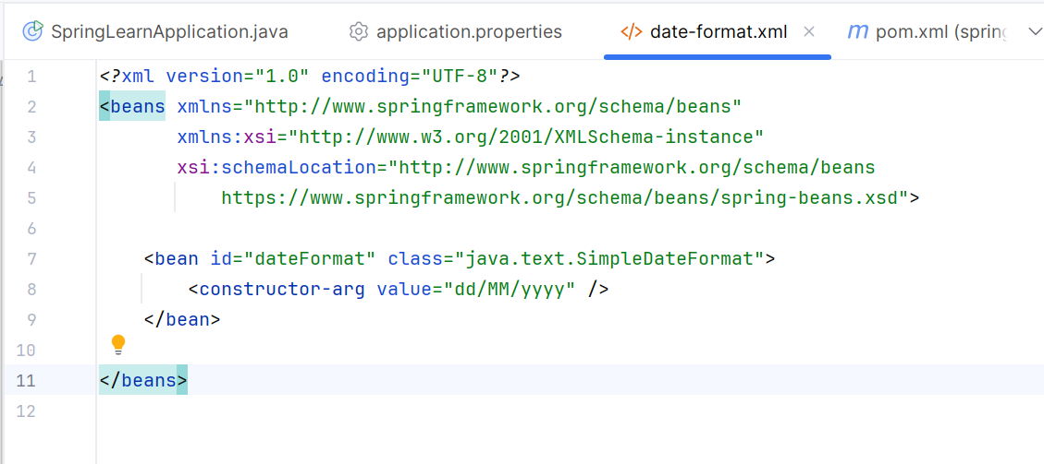

**output :**

